**ASSIGNMENT NO 2**

**NAME:**

Hareem Mohal

**REG NO:**

SP24-BSE-133

**SECTION:** B

**SUBMITTED TO:**

Sir Shahid Bhatti

**DATE:**

22nd Nov,2024

**Primary scene:**



**Gradient Background:**

* Css style used for grandient style background
* Continue button enters main screen
* 3D shadow effect for button

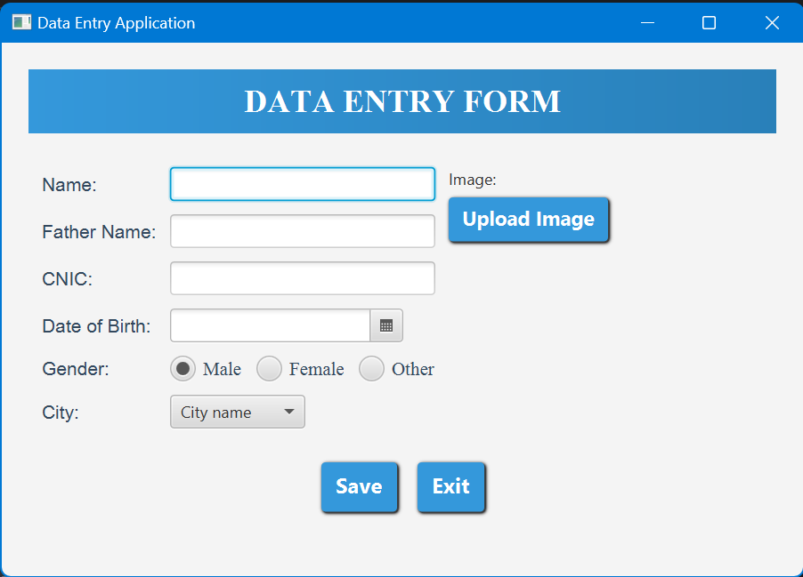**Main Scene:**

**Text Fields:**

* Text fields for Name, Father name, Cnic
* It takes string input

**Radio Buttons:**

* Radio buttons used for gender
* Only one input at a time is allowed for gender

**Combo Box:**

* Combo box for city
* List of different cities is given
* By default it given hint of city name

**ArrayList of Person:**

* All the data entered gets saved in array list of person class when user press save button.

**Confirmation Scene:**

**OK Button:**

* Ok button returns to main scene and clears the fields to enter new data.

**EXIT Button:**

* Exit button closes the application.

